
FURTHER MATHEMATICS
TRIAL EXAMINATION 2
SOLUTIONS
2012

SECTION A

Core - solutions

Question 1

- The mode is the most frequently occurring score. The mode is 11.

(1 mark)

- The median is the middle score when the data is ordered from lowest to highest.
Since there is an even number of scores the middle scores are 12 and 12 so the median is 12.
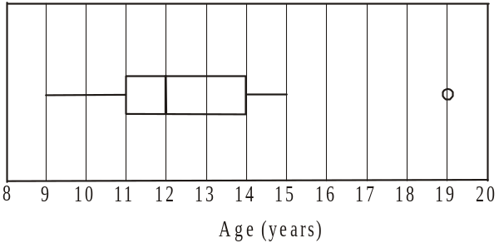

(1 mark)

- Again, using the ordered data,

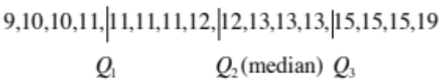

We see that 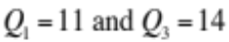.
So the interquartile range (IQR)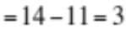.

A piece of data is an outlier if it is greater than
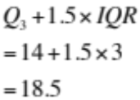
(1 mark)
Since 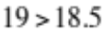, then the data value 19 has correctly been shown as an outlier.
(1 mark)

Question 2

- Of those who last attended a regional school, the percentage that left before the age of 18 was
(1 mark)
- From the table we see that the percentage of students leaving school at age 15 increases with location of school, from 16.2% for urban to 40.6% for remote. This indicates that the age at which a student leaves school is related to the location of their last school.
You could also use the argument that
- The percentage of students leaving school at age 16 increases with the location of the school from 24.3% for urban to 37.1% for remote OR
- The percentage of students leaving school at age 17 decreases with the location of the school from 30.6% for urban to 10.3% for remote OR
- The percentage of students leaving school at age 18 decreases with the location of the school from 26.5% for urban to 11.6% for remote OR
- The percentage of students leaving school at age 19 decreases with the location of the school from 2.4% for urban to 0.4% for remote.
(1 mark) using appropriate percentages
(1 mark) making correct argument
(i.e. increase/decrease across a row)
Question 3
- The independent variable is mother’s age.
(1 mark)

- Use a calculator to find the least squares regression line.

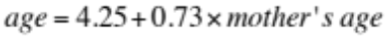
(1 mark) for the 4.25
(1 mark) for the 0.73
- i. Again from your calculator, the coefficient of determination, 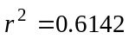(correct to 4 decimal places)
(1 mark)

- 61.42% of the variation in the age at which these adults left school can be explained by the variation in the age at which their mother left school.
(1 mark)
Question 4
- The equation of the trend line is .
The gradient of this line; that is 0.083 gives the increase each year. So the average age will increase by 0.083 years each year.
(1 mark)

- The actual value is 14.2 years (given).
The predicted value is found using the equation of the trend line.
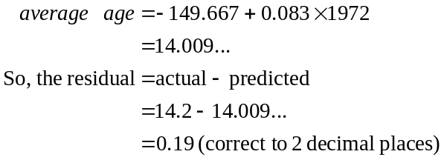
(1 mark)
(1 mark)
Total 15 marks
SECTION B

Module 1: Number patterns

Question 1

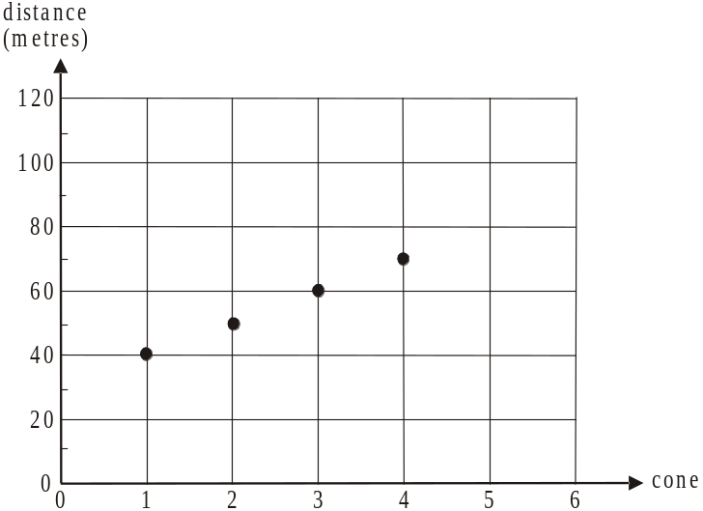

(1 mark)

- Since the arithmetic sequence is 40,50,60,70,… the common difference is 10.
(1 mark)

- Method 1 – using CAS
Generate the sequence.
The term 700 is the 67th term in the sequence.
The car was next to the 67th cone.
(1 mark)
Method 2 – using the formula
Since we have an arithmetic sequence with 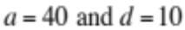,
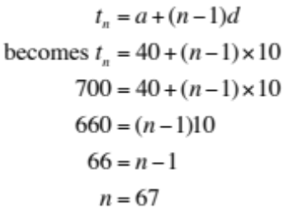
The car was next to the 67th cone.
(1 mark)

- Method 1 – using CAS
Use CAS to generate the arithmetic sequence. The 98th term is 1010.
The road works extended for 1010 metres.
(1 mark)

Method 2 – using the formula
From part c. Method 2 we have
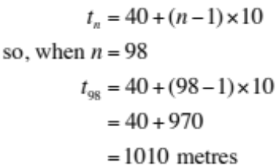
The road works extended for 1010 metres.
(1 mark)

- Start by finding the sum of the first 18 terms of the arithmetic sequence using the formula
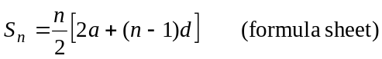
where 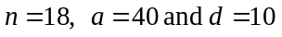
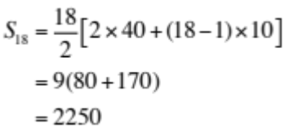
(1 mark)
Since the worker walks from the start of the roadworks to each cone and back he walks in total 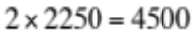metres.
(1 mark)

Question 2

- i. The amount of water in the second barrier is 80% of 200=160 litres.
(1 mark)

- Since each successive barrier is filled with 80% of the water put in the previous barrier we have a geometric sequence.

Method 1 – using CAS
Generate the sequence. The tenth term is 26.8 (correct to 1 decimal place).
(1 mark)
Method 2 – using a formula
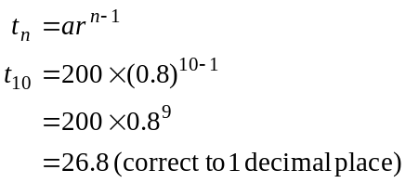
(1 mark)

- Method 1 – using CAS
Generate the sequence.
The 16th term is 7.03687…
So the 16th barrier is filled with approximately 7 litres of water.
(1 mark)
Method 2 – using the formula and CAS
From part a. ii Method 2
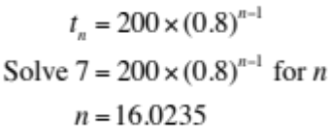 using CAS
So the 16th barrier is filled with approximately 7 litres of water.
(1 mark)

- We want to find the sum of an infinite number of terms of a geometric sequence.
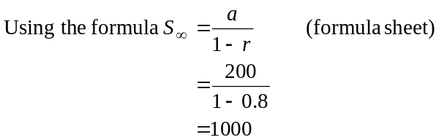
The driver would use 1000 litres.
(1 mark)

Question 3

- 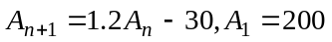
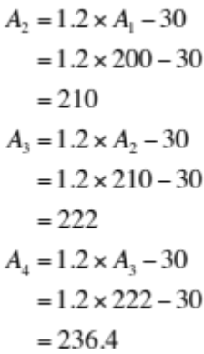
There are 236.4 litres put in the 4th barrier in the line.
(1 mark)

- Use CAS to generate the sequence. The difference between the first two terms is 10L, between the next two is 12L and so on. The difference between the 4th and 5th terms is 17.28, the difference between the 5th and 6th terms is 20.736. So the 6th barrier is the first in the line to have 20L more water put in it than the previous barrier.
(1 mark)

- 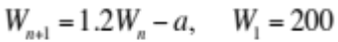
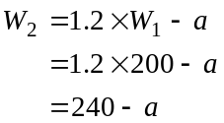
If 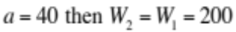.
This generates a sequence of the same number i.e. 200.
So 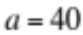.
(1 mark)
Question 4

- distance of second cone from the start of the road works is
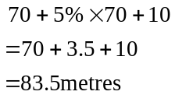
(1 mark)

- We know that 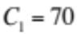, that is the distance of the first cone from the start of the road works is 70m.
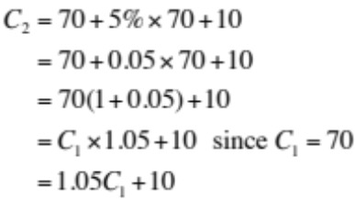
Generalizing this,
(1 mark)
Total 15 marks

Module 2: Geometry and trigonometry

Question 1

- Since the distance from the front wall to the back wall of the theatre is 22m and
In 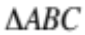
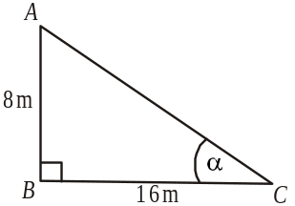
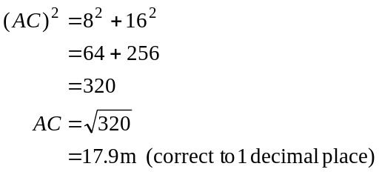
(1 mark)

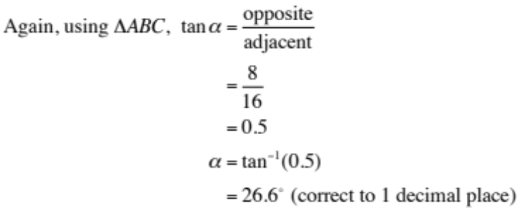

(1 mark)

- In 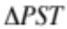
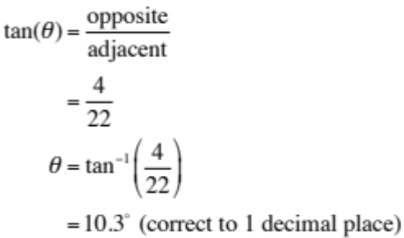
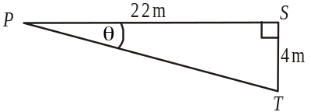
(1 mark)

- The angle of depression of point T from point P is 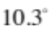.
(1 mark)

Question 2

- The distance on the contour map from the seat at point S to point L is 6cm so the horizontal distance from the seat to point L is 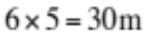.
The difference in height between the seat and point L is given by the contours i.e., 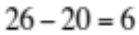
Using Pythagoras,
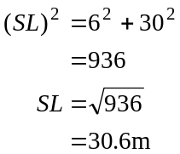
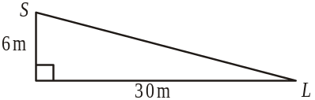
(1 mark)

- Method 1
The average slope between the seat and point L is given by
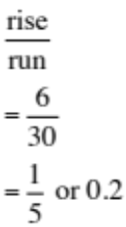
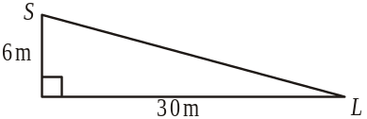
(1 mark)

Method 2
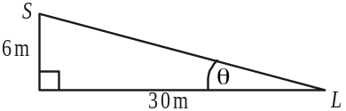
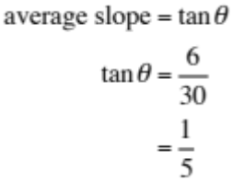
So average slope is 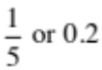.
(1 mark)

Question 3

- Since the building is a regular pentagon, the size of one of its 5 interior angles is given by
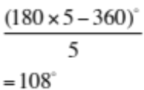
Since is half one of these interior angles, 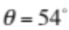.
(1 mark)

- In 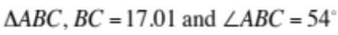because it is an isosceles triangle.
Also 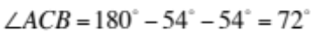
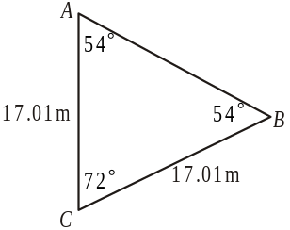

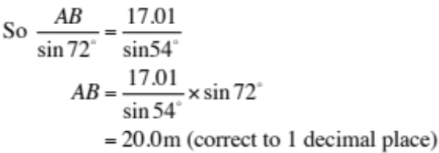

(1 mark)
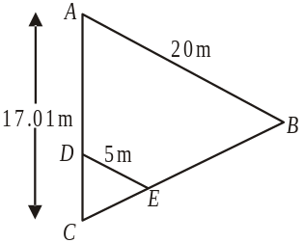
- 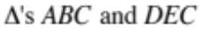are similar.
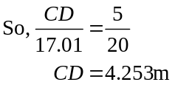
(correct to 3 decimal places)

(1 mark)

- From part a., 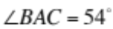.
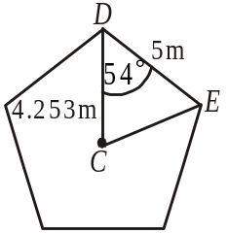
From part c., 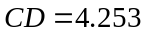.
The area of 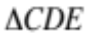 can be found using the formula
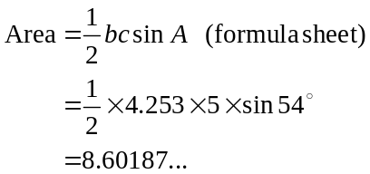
(1 mark)
Since the pentagon is regular the area of the storeroom is
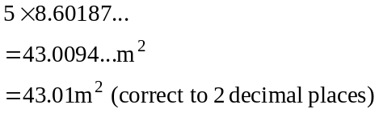
(1 mark)

Question 4

- In 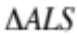, use the cosine rule
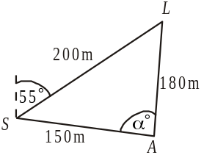
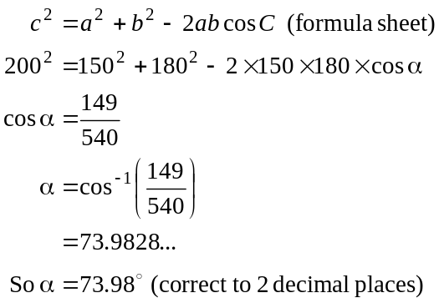
(1 mark)

- Find 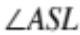.
Again in but this time using the sine rule,
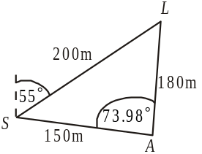
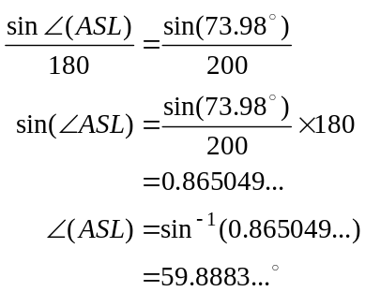
So the bearing of A from S is
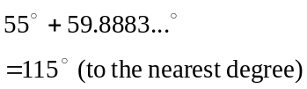
(1 mark)
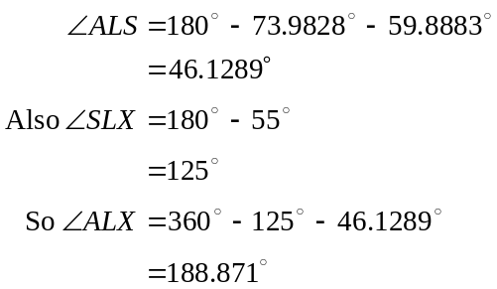
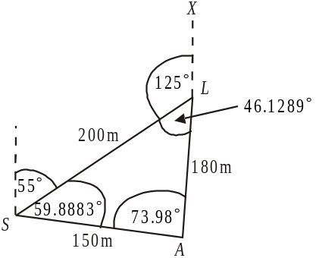

So the bearing of A from L is 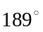 (to the nearest degree).

(1 mark) for finding 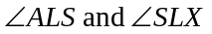

(1 mark) for correct answer
Total 15 marks

Module 3: Graphs and relations.

Question 1
- 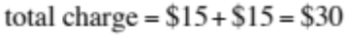
(1 mark)
b.
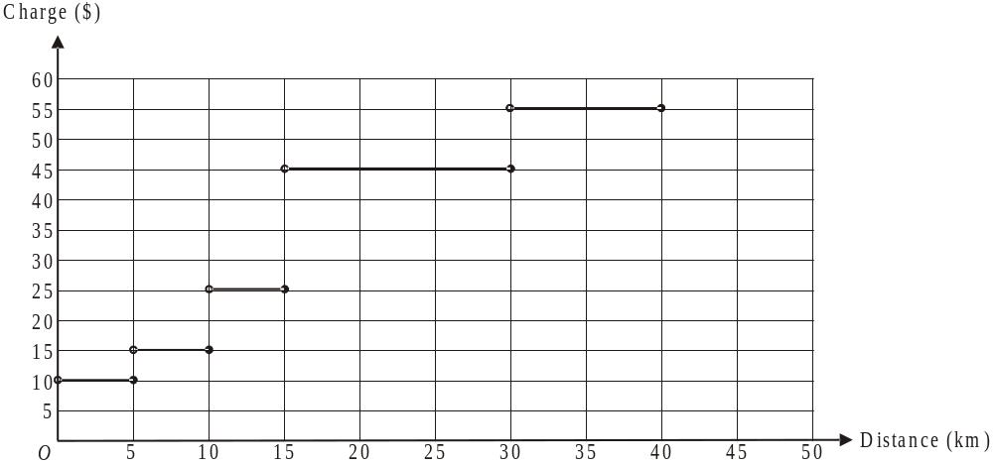
(1 mark)
c. 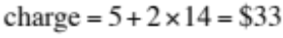
(1 mark)
d. Sketch the graph of 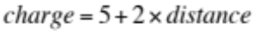
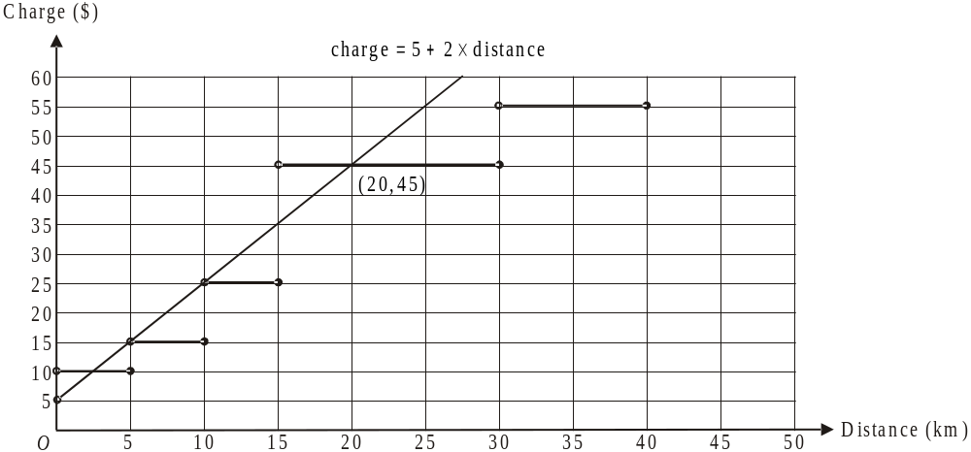
From the graph we see that the new charges and the old charges are the same for a distance of 20km since the line with equation meets the step graph at the point 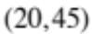.
So for distances greater than 15 and less than 20, the new charges are cheaper than the old charges.
Alternatively 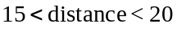.
(1 mark) – finding the point where the old and new charges are equal
(1 mark) – correct answer

e. Since the line passes through 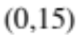 the value of a is 15.
The gradient of the line is given by 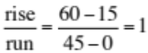
So the value of b is 1.
(1 mark)

f. The right endpoint of the line is included and is 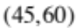. The maximum distance that the courier business will deliver documents is 45km.
(1 mark)

Question 2

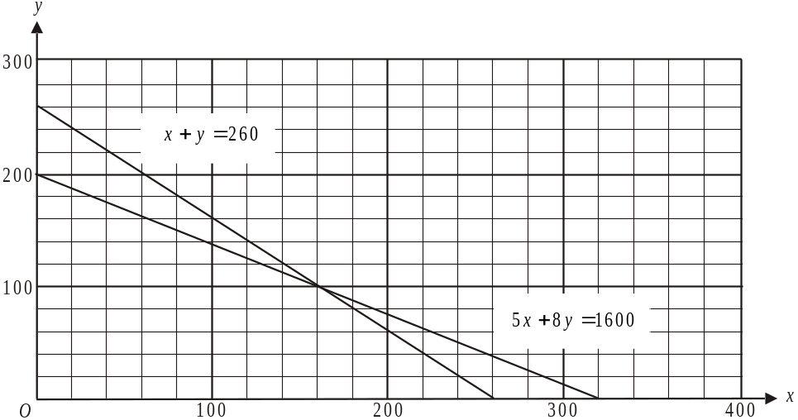

(1 mark)

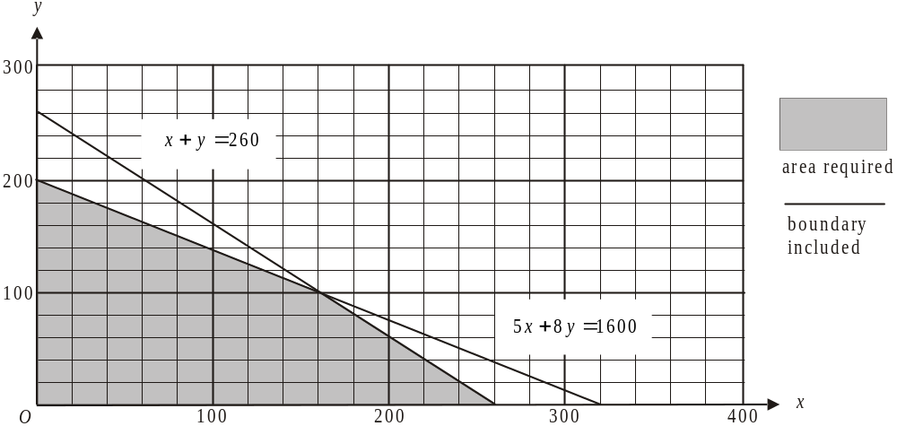

(1 mark)

- 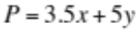
(1 mark)

- i. Maximum profit occurs at a corner point of the feasible region.
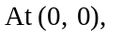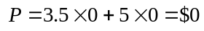
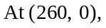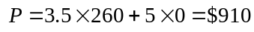
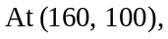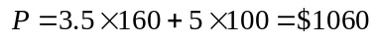
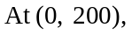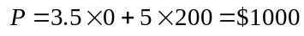
So the maximum profit is $1060.
(1 mark)

- From part i., the maximum profit occurs when 100 large parcels are delivered.
(1 mark)

e. i. Constraint 2 is changed to 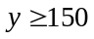. The new feasible region is shaded
below.
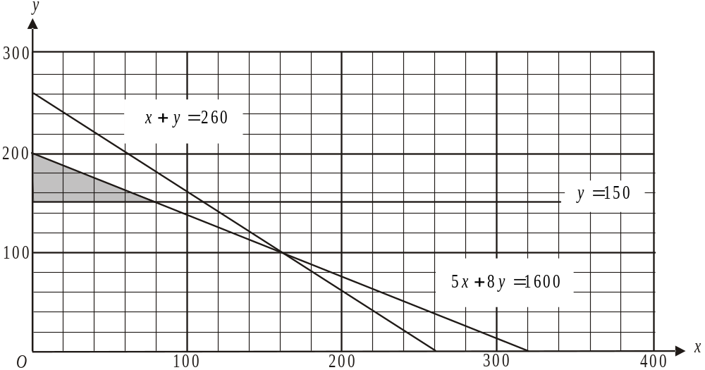

The new feasible region has corner points at 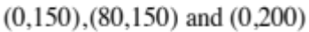.
The new expression for profit is 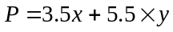 (1 mark)

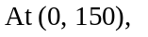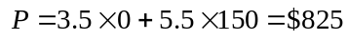
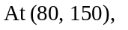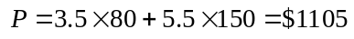
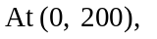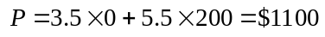
So the maximum profit is $1105.
(1 mark)
ii. To make this maximum profit the courier business needs to deliver 80 small parcels and 150 large parcels.
(1 mark)
Total 15 marks
Module 4: Business-related mathematics.

Question 1
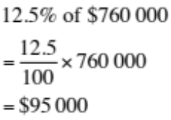

(1 mark)

- 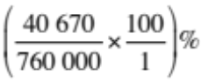
(1 mark)

- Lucy and Bernie made a capital gain of 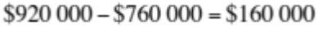 on the sale of the property.
Therefore they had to pay
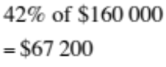
(1 mark)

Question 2

- Bernie paid 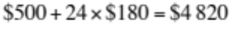in total.
Of this, $4820-$4500=$320 was in interest.

(1 mark)
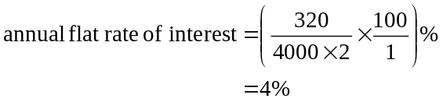

Note that we use the original price minus the deposit. Also the arrangement is for 2 years so we have to divide by 2.
(1 mark)
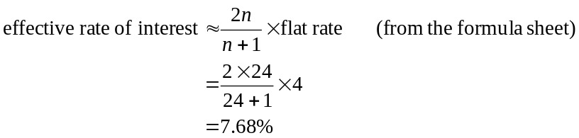

Note that n is the number of periods i.e. months in this case over which the agreement ran.
(1 mark)

Question 3

- Using TVM, we have
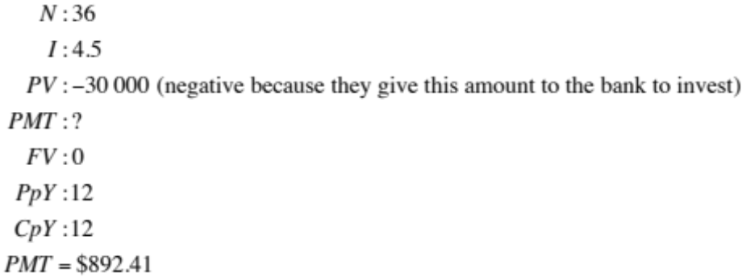
Lucy and Bernie receive monthly payments of $892.41.
(1 mark)

    - Again, using TVM, we have
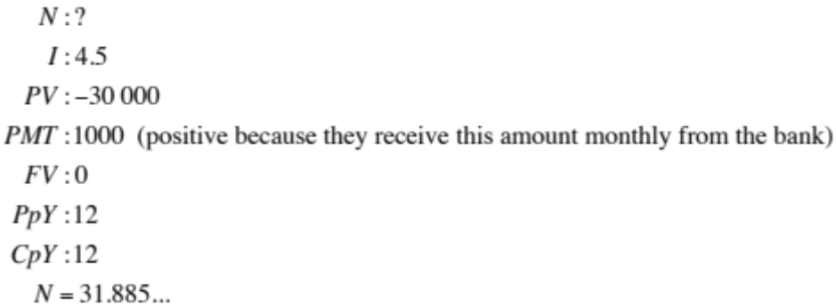
So the annuity would have lasted for 32 months (to the nearest whole month).
(1 mark)

    - The annual amount paid from a perpetuity would have been
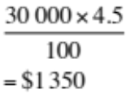
The monthly amount paid would be $112.50.
(1 mark)

Question 4

- 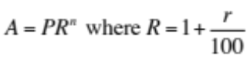 (formula sheet)
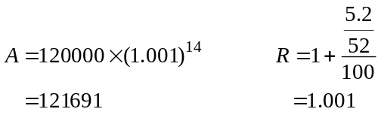

Lucy and Bernie earned 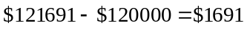 in interest to the nearest dollar.
(1 mark)
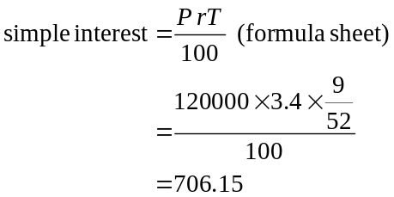

They earned $706.15.
(1 mark)

Question 5

- Using TVM
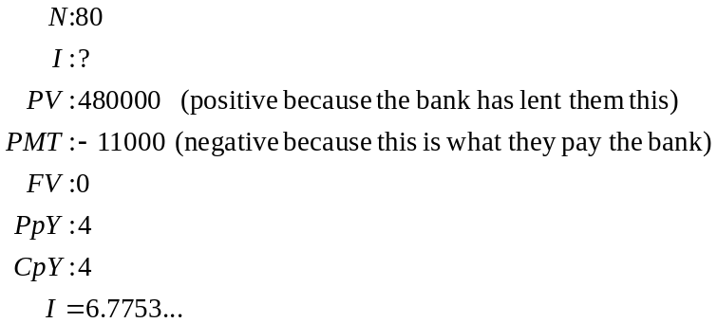
The annual interest rate is 6.78% correct to two decimal places.
(1 mark)

- Using TVM
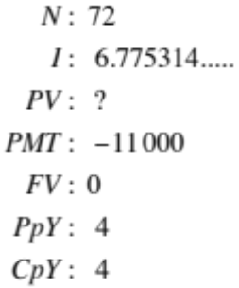
Two years (i.e. 8 quarters) into the loan, there are 72 payments to go. The principal remaining is $455 634.94.
(1 mark)

- i. Using TVM,
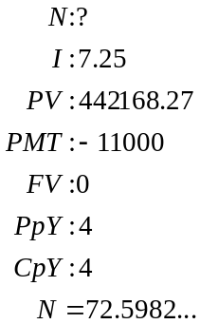
It will take 72.59…quarters to pay out the loan from this point in time. Had interest rates remained the same, 3 years into the loan there would have been a further 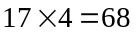 quarters for the loan to run. So an extra 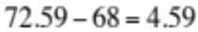 or 5 (to the nearest whole quarter) have been added to the loan.
(1 mark)

- In the first 3 years Lucy and Bernie pay 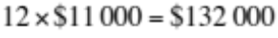.
In the next 17 years plus 4.598 quarters or 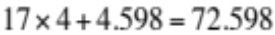 quarters they pay 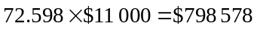.
Total payment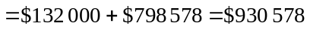
Interest paid over the whole loan
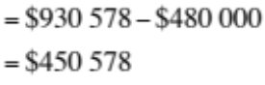
(1 mark)
Total 15 marks
Module 5: Networks and decision mathematics

Question 1

- By inspection, the shortest route is A C D F, so the shortest distance is 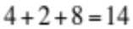km.
(1 mark)

- Because Dan’s route starts and finishes at the same worksite it is a circuit. Because Dan’s route passes through each of the other worksites just once it is Hamiltonian.
The required term is a Hamiltonian circuit.
(1 mark)

- Dan’s route on this day is an Euler path. The starting and finishing vertices on a network containing an Euler path will have odd degrees whilst all other vertices will have even degrees. Only the vertices representing worksites A and B have odd degrees so these are the required two worksites.
(1 mark)

Question 2
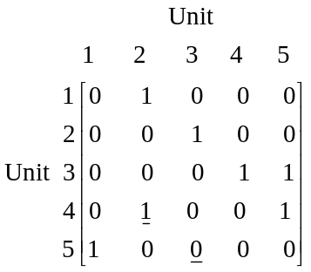

Unit 2 can be reached from Unit 4 in one step whereas Unit 3 cannot be reached from Unit 5 in one step.
(1 mark) – for 1
(1 mark) – for 0

- Construct an adjacency matrix for the number of two-step routes.
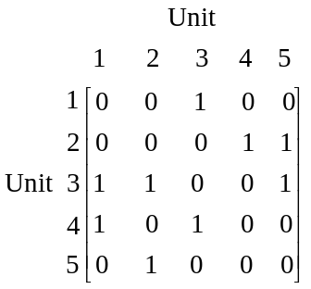
Adding the one-step and two-step adjacency matrices gives
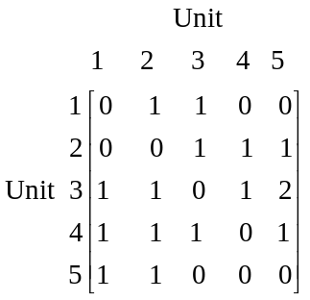

The reachability score for each of the Units is obtained by summing each column.

Unit 1 | Unit 2 | Unit 3 | Unit 4 | Unit 5
3 | 4 | 3 | 2 | 4

So Units 2 and 5 are the most reachable.
(1 mark)
Unit 4 is the least reachable.
(1 mark)

Question 3

- The flow of 5 litres/sec through one of the pipes does not flow into the 1st stormwater drain so we count this flow as zero. The minimum cut through this top part of the network that flows into the 1st stormwater drain is shown below and is 50 litres/sec.
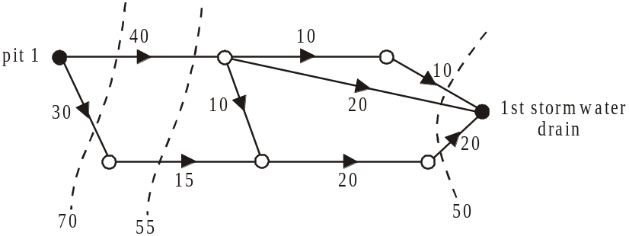

Therefore the maximum rate at which water can flow into the 1st stormwater drain is 50 litres/sec.
(1 mark)
We include the flow of 5 litres/sec through one of the pipes in the bottom part of the network that flows into the 2nd stormwater drain.
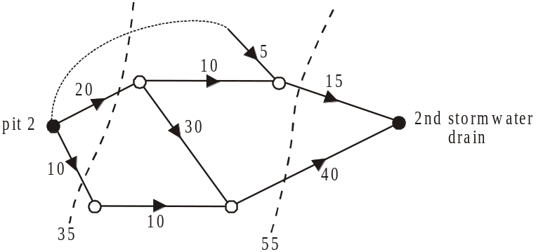

Even though the pipe with the 5 litres/sec flow doesn’t enter the network at pit 2 it leaves the network at the 2nd stormwater drain and so the maximum rate in litres per second that water can flow through the network into the 2nd stormwater drain is 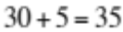 litres/sec.
(1 mark)

- We want to maximize the water that runs into the 2nd stormwater drain. In the top part of the network there is a potential capacity of 30 litres/sec in the pipe running from pit 1 to the start of the new pipe. So up to 30 l/sec can run through this new pipe.
In the bottom part of the network where the new pipe enters there is spare capacity of 20 l/sec.
So the minimum flow rate that this new pipe should have is 20 l/sec.
(1 mark)
Question 4

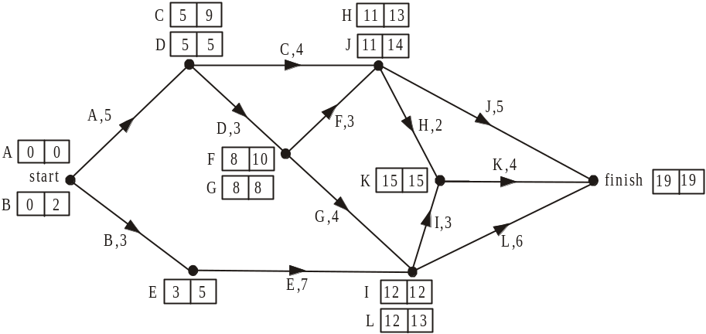

Find the earliest and latest start times for each of the activities.

- The latest start time for activity F is 10 days.
(1 mark)

- The activities A, D, G, I, K, lie on the critical path.
(1 mark)

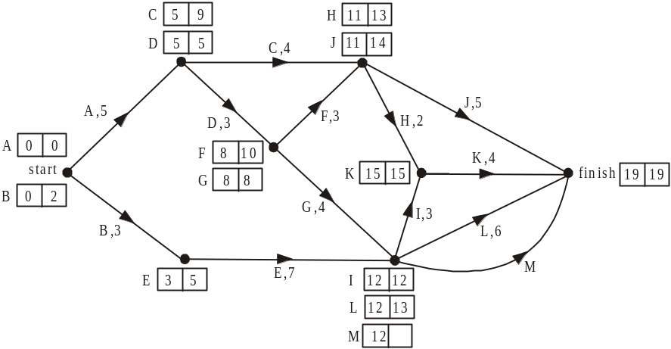

Since activity M has as its immediate predecessor’s activities E and G and is not an immediate predecessor to any other activity it can be included on the network as shown above.
Since activity M cannot delay the project, the maximum time it can take is 7 days since 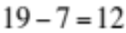.
(1 mark)

- Those activities that didn’t lie on the critical path, together with their float times are shown below.

Activity | Float Time
B | 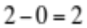
C | 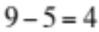
E | 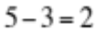
F | 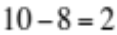
H | 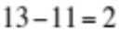
J | 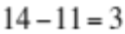
L | 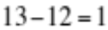

The activity that would have delayed the project was activity J because it had 3 float days. Because it ran 4 days late it delayed the completion of the project by 1 day.
(1 mark)

- Activity C has a float time of 4 days so it could have run late and not delayed the project.
(1 mark)
Total 15 marks

Module 6: Matrices

Question 1
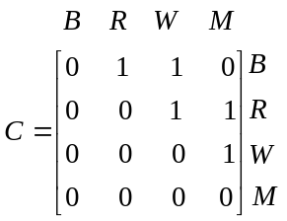

(1 mark)

- i. The column of zeros (under B) indicate that the builders do not supply the builders, retailers, wholesalers or manufacturers.
(1 mark)

  - The row of zeros, (in the M row) indicate that none of the builders, the retailers, the wholesalers or manufacturers supply the manufacturers.
(1 mark)

Question 2

- 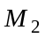 supplies of the items this month.
(1 mark)

- 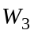 receives of the items.
(1 mark)

- 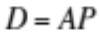
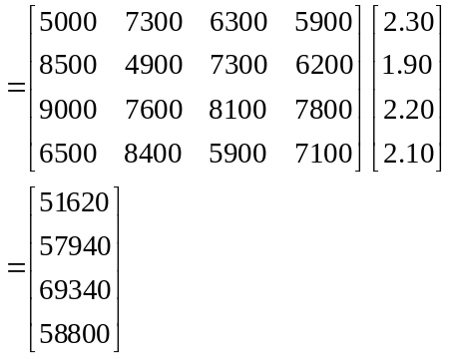
(1 mark)

- The entry 51 620 in matrix D represents the total amount spent this month by wholesaler 1 in purchasing this item from the 4 different manufacturers.
(1 mark)

Question 3
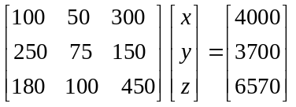

(1 mark)

- Using the matrix equation (above) and CAS, we have
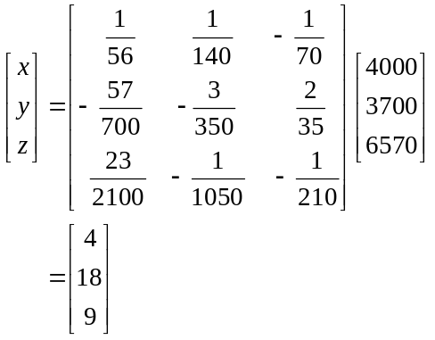

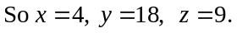

Note that the 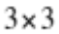 matrix given in the solution is the inverse matrix of
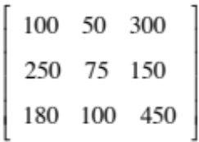
Because the question is worth 2 marks, some working needs to be shown which should include this inverse matrix.
(1 mark) – showing inverse matrix
(1 mark) correct answer

Question 4

- 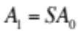
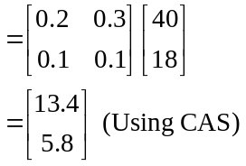
(1 mark)

- 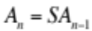
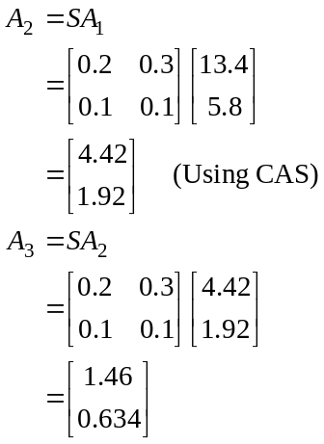
At the end of the third week 0.63 tonnes (correct to 2 decimal places) of product Y will be supplied.
Alternatively,
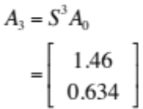
(1 mark)

- Using CAS, keep generating the matrices 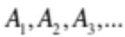
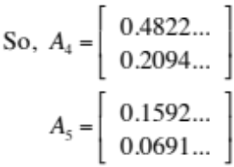
The sum of the elements is 0.2283… which is greater than 0.2.
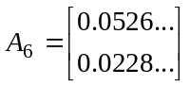
The sum of the elements is 0.0754… which is less than 0.2. So at the end of the 6th week the wholesaler will first charge for delivery.
(1 mark)

- Method 1 – using CAS

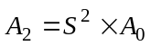
Using CAS, solve 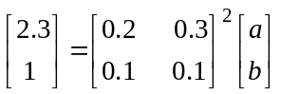 for a where 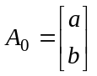.
(1 mark)
So 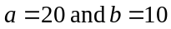; that is, 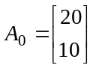.
So, 20 tonnes of product X and 10 tonnes of product Y were initially supplied to the project.
(1 mark)

Method 2
Since ,
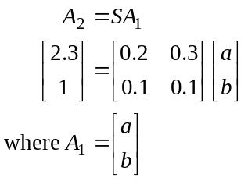
Premultiply both sides of the equation by the inverse of S.
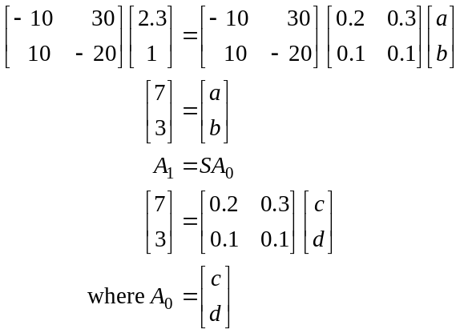
Premultiply both sides of the equation by the inverse of S.
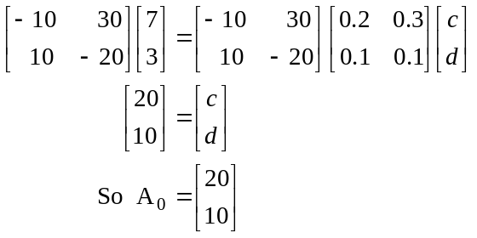
So, 20 tonnes of product X and 10 tonnes of product Y were initially supplied to the project.
(1 mark) – finding 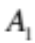
(1 mark) – finding 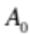
Total 15 marks

